

**Organization Name:** Southern Shine NC

**Project Name:** Network Infrastructure Upgrade Proposal

Evynne, Lily, Ricky, Will, Gray

Southern Shine NC's network project delineates the areas of their current network infrastructure that will be analyzed and potentially upgraded to optimize performance and efficiency.

**Company Liaison:**

**Statement of Approval:**  
 **I, Riccardo Pradieu, Chief Operations Officer of Southern Shine NC, hereby acknowledge that I have received and approved the scope of the Network Infrastructure Upgrade Proposal as outlined by the team members listed above.**

[Signature: Riccardo Pradieu]  
 [Date: [3/19/2024]]

397 Park Ave Youngsville NC 27596

rickypra040@gmail.com

**Report Purpose**

This report aims to provide an analysis of Southern Shine NC's IT governance structure and enterprise architecture to enhance understanding and optimize IT resources for business efficiency and growth.

**Company Overview**

Southern Shine NC is a locally owned cleaning services company based in Raleigh and Wake Forest, NC. Established in 2020, the company offers a range of residential and commercial exterior cleaning services, including pressure washing, gutter cleaning, window cleaning, and more.

**IT Governance Structure**

Southern Shine NC's IT governance structure encompasses policies, processes, and decision-making frameworks to ensure effective management and utilization of IT resources. The structure includes designated IT roles, responsibilities, and communication channels. (Include IT governance diagram here)

**Enterprise Architecture Description**

Southern Shine NC's enterprise architecture defines the organization's IT infrastructure, applications, data architecture, and technology standards. It aligns IT capabilities with business objectives to support operational efficiency and strategic initiatives.

**Network Project Scope**

The network project aims to optimize Southern Shine NC's IT infrastructure to ensure reliable and efficient delivery of cleaning services. It encompasses the design, implementation, and management of network systems, including hardware, software, and connectivity solutions. Key objectives include improving network performance, enhancing security measures, and enabling scalability to accommodate business growth.

**Current/Baseline Network Description**

Southern Shine NC's current network infrastructure consists of a combination of wired and wireless technologies to support internal operations, client communications, and service delivery. The network includes servers, workstations, printers, and other networked devices distributed across multiple locations in Raleigh and Wake Forest, NC.

**Logical Network Diagram**

The logical network diagram illustrates the network topology, including the arrangement of devices, connections, and communication protocols. It depicts the logical relationships between network components and the flow of data between them.

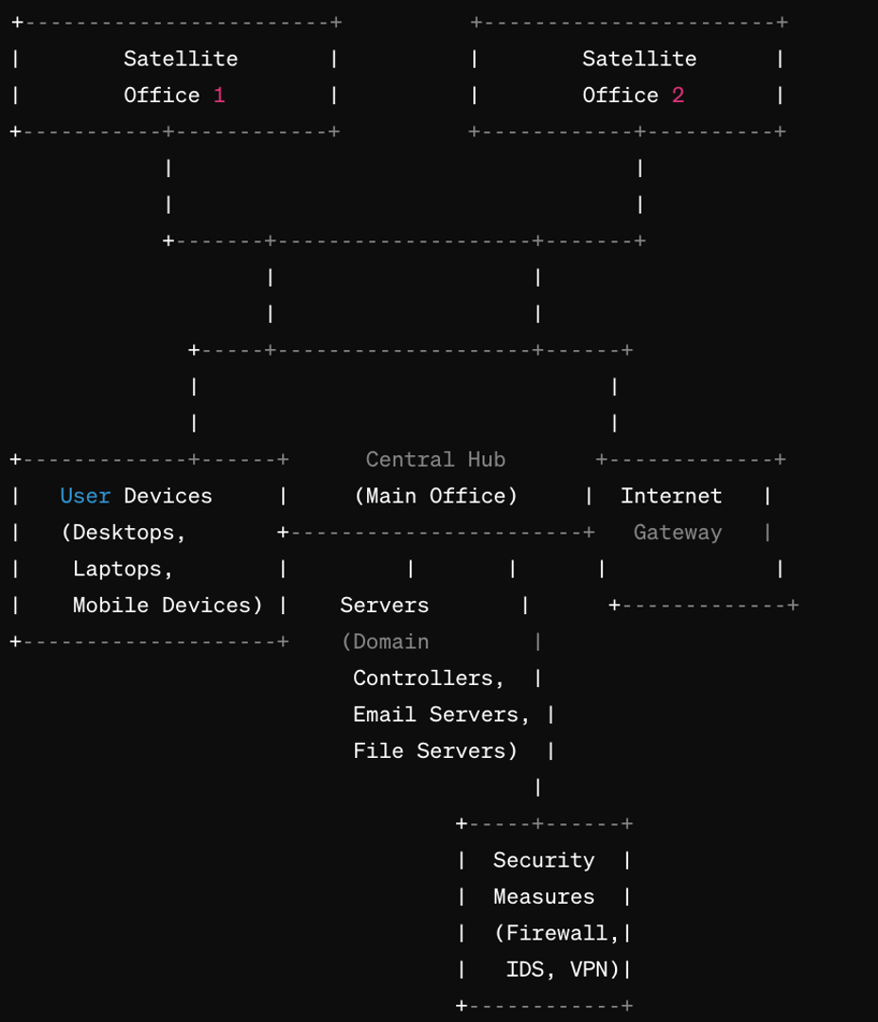

**Physical Network Diagram**

The physical network diagram provides a visual representation of the actual hardware components comprising the network infrastructure. It outlines the physical layout of servers, switches, routers, access points, and other networking equipment deployed within Southern Shine NC's premises.

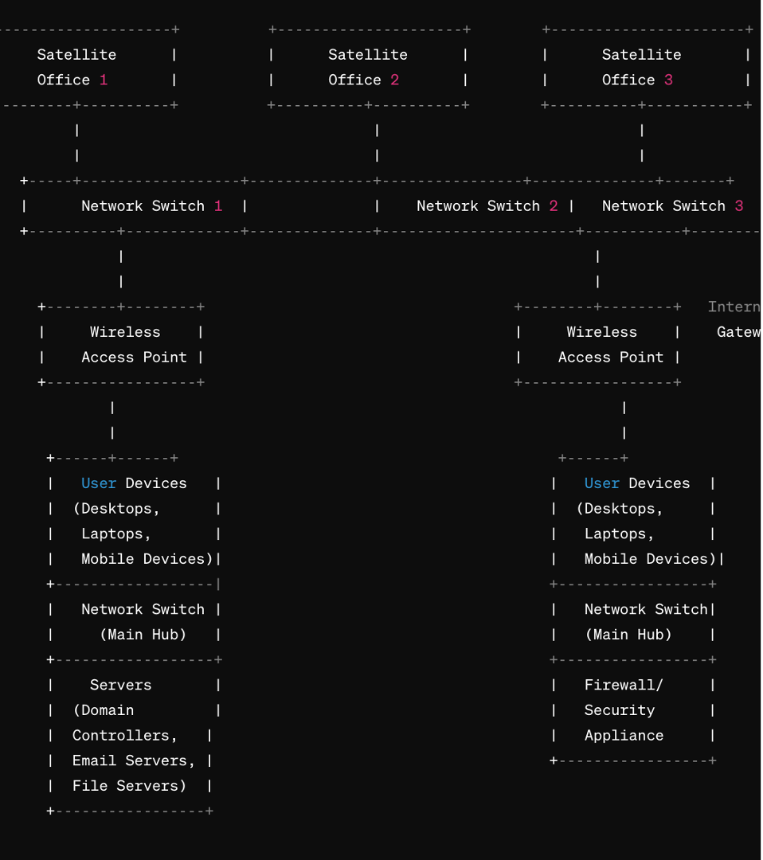

**Current Network Infrastructure**

The current network infrastructure of Southern Shine NC comprises a combination of wired and wireless technologies to support its business operations.

**Topology**

The network topology consists of a centralized structure with a main office location serving as the hub, connecting to satellite offices or remote sites.

**Equipment and Devices**

The network includes routers, switches, access points, and servers to facilitate data transmission and communication across different locations.

**Security Measures**

Basic security measures such as firewalls and antivirus software are implemented to safeguard the network from external threats.

**Scalability**

The existing network demonstrates limited scalability to accommodate potential growth and increased demand for network resources.

**Network Assessment**

Conduct a comprehensive assessment of the current network infrastructure, including performance, security vulnerabilities, and scalability.

**Identify Requirements**

Determine the specific requirements and objectives of the network project, considering factors such as business goals, user needs, and technology advancements.

**Design Phase**

Develop a detailed network design plan to address the identified requirements, including recommendations for hardware upgrades, security enhancements, and network optimization.

**Implementation**

Implement the proposed network design plan in a phased approach, ensuring minimal disruption to ongoing business operations.

**Testing and Optimization**

Conduct thorough testing and optimization procedures to validate the effectiveness and reliability of the new network configuration.

**Training and Documentation**

Provide training sessions for employees to familiarize them with the updated network infrastructure and document all network configurations and procedures for future reference.

**By following these next steps**

Southern Shine NC can enhance its network infrastructure to better support its business objectives and ensure seamless communication and connectivity across all locations.